PROJECT-16
AI LINKDEN POST GENERATOR
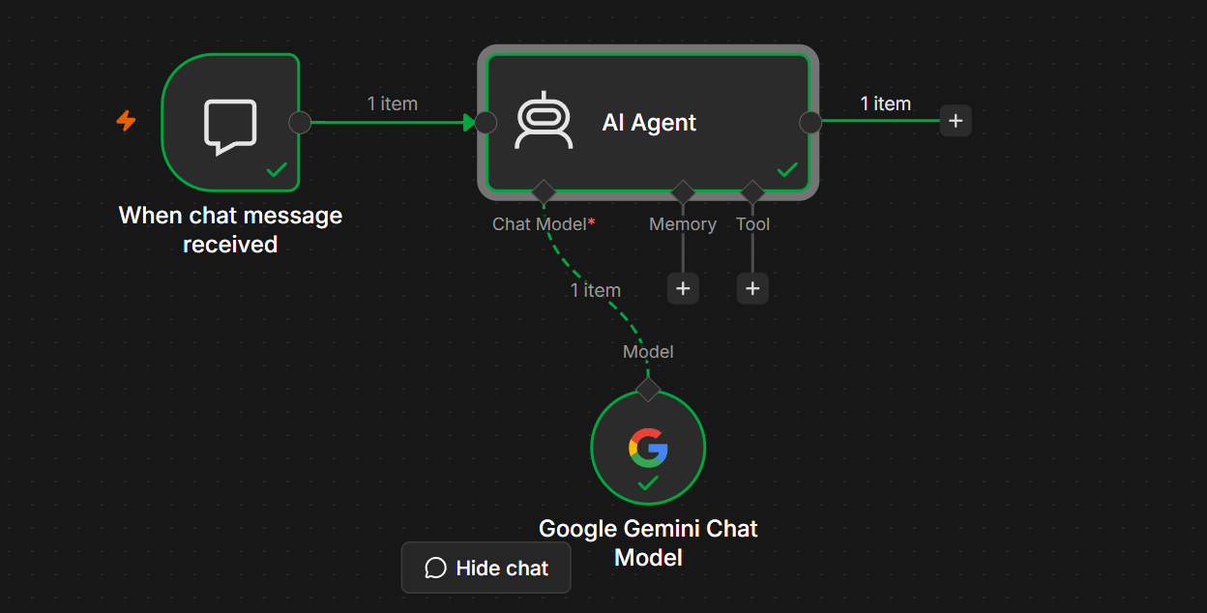
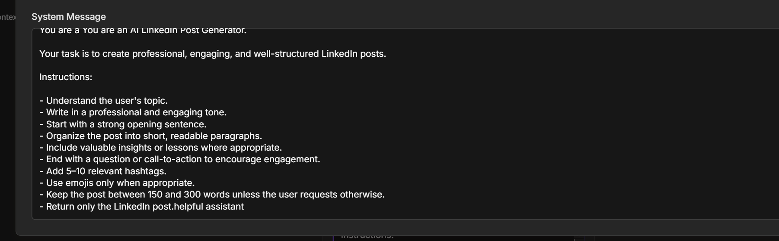
Project Objective
The objective of this project is to build an AI-powered LinkedIn Post Generator that creates engaging, professional, and high-quality LinkedIn posts based on a user's topic or idea.
The AI Agent can generate:
- Professional LinkedIn posts
- Personal branding posts
- Career updates
- Job announcements
- Product launches
- Company updates
- Technology insights
- Educational posts
- Success stories
- Motivational posts

Workflow Architecture
User
│
▼
When Chat Message Received
│
▼
AI Agent
│
▼
Google Gemini Chat Model
│
▼
Generated LinkedIn Post

Workflow Components
Step | Node | Purpose
1 | When Chat Message Received | Receives the user's request
2 | AI Agent | Understands the topic and prepares the prompt
3 | Google Gemini Chat Model | Generates the LinkedIn post

Prerequisites
Before building this project, ensure you have:
- n8n (Cloud or Self-hosted)
- Google AI Studio API Key
- Google Gemini Chat Model configured
- Internet connection

Step 1 – Create Workflow
Open n8n
Click
New Workflow
Rename it
AI LinkedIn Post Generator

Step 2 – Add Chat Trigger
Add
When Chat Message Received
Purpose
Receives the user's request.
Example Input
Write a LinkedIn post announcing that I completed an AI and n8n automation course.
Output
{
"chatInput":"Write a LinkedIn post announcing that I completed an AI and n8n automation course."
}

Step 3 – Add AI Agent
Connect
When Chat Message Received
│
▼
AI Agent
Configure
Source for Prompt
Connected Chat Trigger Node
Prompt
{{$json.chatInput}}

Step 4 – Configure the System Prompt
Paste the following into the System Message.
You are an AI LinkedIn Post Generator.

Your task is to create professional, engaging, and well-structured LinkedIn posts.

Instructions:

- Understand the user's topic.
- Write in a professional and engaging tone.
- Start with a strong opening sentence.
- Organize the post into short, readable paragraphs.
- Include valuable insights or lessons where appropriate.
- End with a question or call-to-action to encourage engagement.
- Add 5–10 relevant hashtags.
- Use emojis only when appropriate.
- Keep the post between 150 and 300 words unless the user requests otherwise.
- Return only the LinkedIn post.

Step 5 – Add Google Gemini Chat Model
Click
+ Chat Model
Choose
Google Gemini Chat Model
Configuration
Setting | Value
Provider | Google Gemini
Model | Gemini 2.5 Flash (or another available Gemini model)
Authentication | Google AI Studio API Key
Connect it to the AI Agent.

Final Workflow
When Chat Message Received
│
▼
AI Agent
│
▼
Google Gemini Chat Model

Workflow Execution
Step 1
User enters
Write a LinkedIn post about learning AI Agents with n8n.
↓
Step 2
Chat Trigger receives the request.
↓
Step 3
AI Agent understands the request.
↓
Step 4
The prompt is sent to the Google Gemini Chat Model.
↓
Step 5
Gemini generates a professional LinkedIn post.
↓
Step 6
The post is returned to the user.

Sample Inputs and Outputs
Example 1
Input
Write a LinkedIn post about completing an AI course.
Output
🎉 Excited to share that I have successfully completed an AI course!

This journey helped me strengthen my understanding of Artificial Intelligence, prompt engineering, and workflow automation. I'm excited to continue building practical AI solutions and expanding my skills.

Looking forward to applying these learnings to real-world projects and connecting with others in the AI community.

What AI skill are you currently learning?

#ArtificialIntelligence #Learning #AI #CareerGrowth #Technology

Example 2
Input
Create a LinkedIn post announcing a new product launch.
Output
🚀 We're excited to introduce our latest product!

Designed to simplify workflows and improve productivity, this solution is built with our users in mind. We can't wait to hear your feedback and see how it helps your business.

Have you tried AI-powered automation in your daily work?

#ProductLaunch #Innovation #Technology #Business #AI

Example 3
Input
Write a motivational LinkedIn post for students.
Output
Success isn't about being perfect—it's about showing up consistently.

Every project you complete and every skill you learn brings you one step closer to your goals. Stay curious, keep learning, and don't be afraid to make mistakes.

What new skill are you working on this month?

#Students #CareerGrowth #Learning #Success #Motivation

Example 4
Input
Write a LinkedIn post about AI automation.
Output
🤖 AI automation is transforming the way we work.

By automating repetitive tasks, teams can focus on creativity, strategy, and innovation. Learning tools like n8n opens up countless opportunities to build intelligent workflows without extensive coding.

How are you using AI in your daily work?

#AI #Automation #n8n #Innovation #Productivity

Workflow Diagram
User
│
▼
When Chat Message Received
│
▼
AI Agent
│
▼
Google Gemini Chat Model
│
▼
Generated LinkedIn Post

Error Handling
Error: No Prompt Specified
Cause
The AI Agent did not receive a user request.
Solution
Verify that the Prompt field contains:
{{$json.chatInput}}

Error: Authentication Failed
Cause
Invalid Google Gemini API Key.
Solution
Reconnect or update your Google AI Studio credentials.

Error: Too Many Requests
Cause
Gemini API rate limit exceeded.
Solution
- Wait a few minutes.
- Check your API quota.
- Retry the request.

Learning Outcomes
After completing this project, you will be able to:
- Build an AI content generator in n8n.
- Configure an AI Agent with Google Gemini.
- Design effective prompts for social media content.
- Generate engaging LinkedIn posts automatically.
- Test conversational AI workflows.

Real-World Applications
- Personal branding.
- Company announcements.
- Career milestone posts.
- Product launches.
- AI and technology updates.
- Educational content.
- Recruitment posts.
- Event promotions.
- Thought leadership.
- Professional networking.

Practice Challenge
Enhance this project by adding:
- A post tone selector (Professional, Inspirational, Casual, Technical).
- A post length selector (Short, Medium, Long).
- Automatic hashtag generation based on the topic.
- A Memory node to remember the user's preferred writing style.
- A Google Sheets node to save generated posts.
- A LinkedIn API node (or HTTP Request node) to publish posts automatically.

Final Workflow
User
│
▼
When Chat Message Received
│
▼
AI Agent
│
▼
Google Gemini Chat Model
│
▼
Professional LinkedIn Post
Expected Result
The AI LinkedIn Post Generator accepts a topic or idea from the user, uses the Google Gemini Chat Model to create a polished and engaging LinkedIn post, and returns content optimized for professional networking. This project teaches prompt engineering, AI-powered content generation, and conversational workflow design in n8n, making it a strong foundation for building more advanced social media automation agents.

